**2nd order derivative**

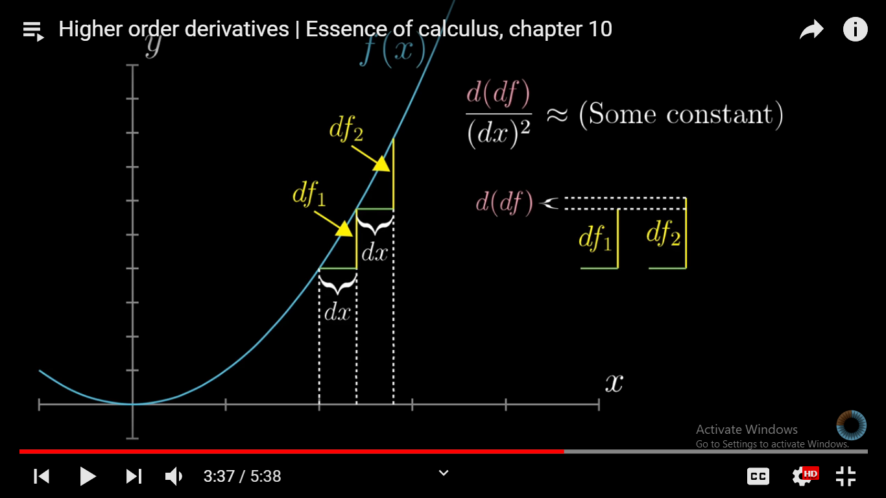

1 example is acceleration here -ve in graph is -ve acceleration

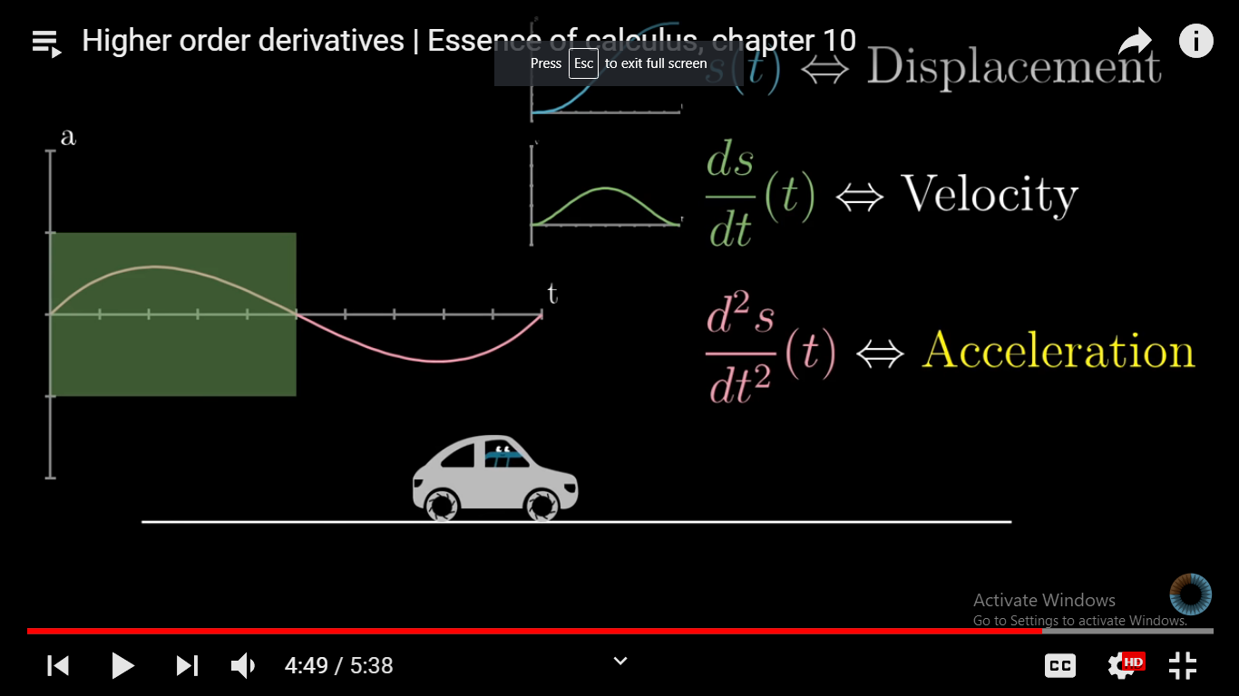

**3rd order derivative example: Jerk : if jerk is not 0 it maens strength of accelaration is itself changing**

